Lab 7 Assignment (Database Systems)

Name = Poorab Gangwani

Class = 4B1

Roll-Number = CS191092

1. Create a view EmployeeView having two columns: First name and Date of Hiring. Show the structure of the view.

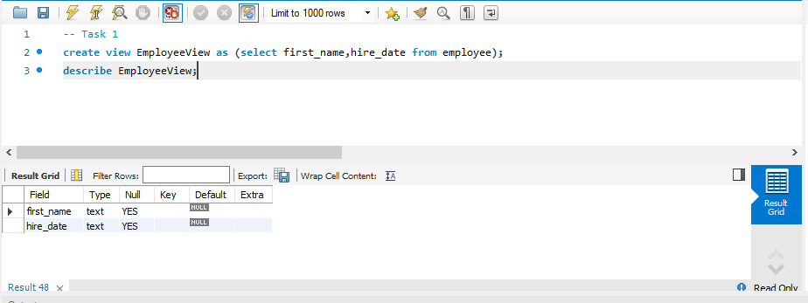

1. Insert a new record in the Employees table. Display all the records in Employees, EmployeeInfo, and EmployeeView.

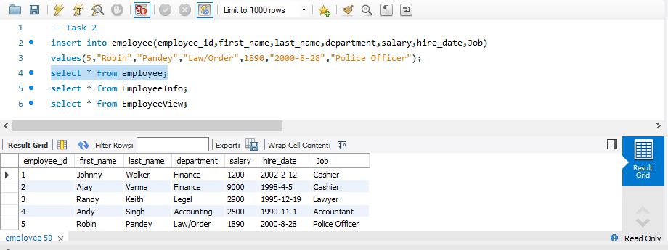

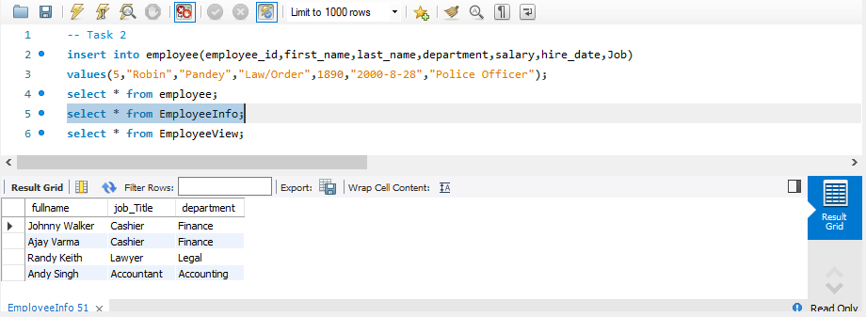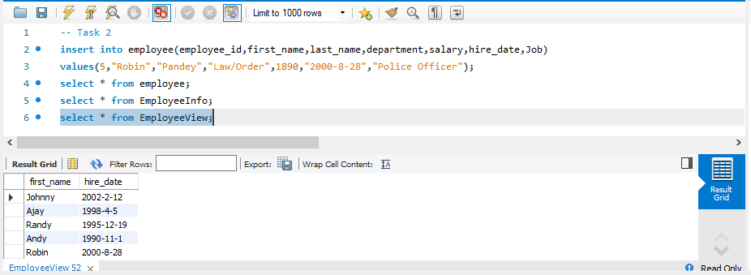

1. Alter EmployeeView to restrict it to show only the employees hired in 2020.

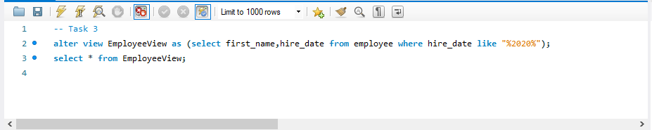

1. Using EmployeeView, add a new employee with hiring date “19-12-2012”. Display all the records in Employees, EmployeeInfo, and EmployeeView.

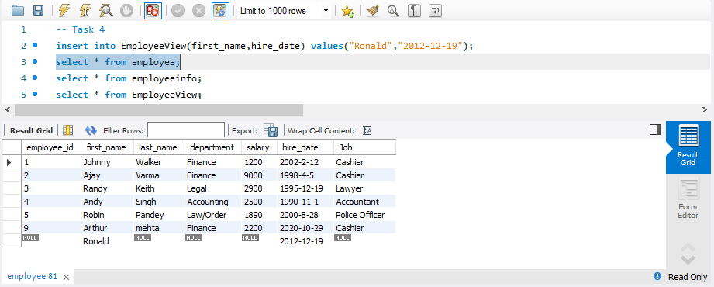

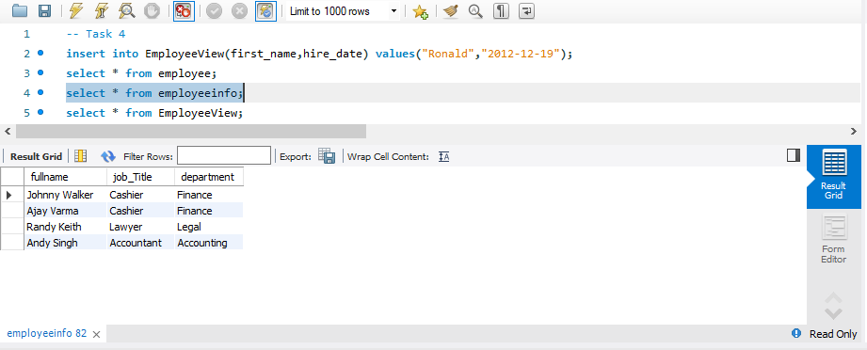

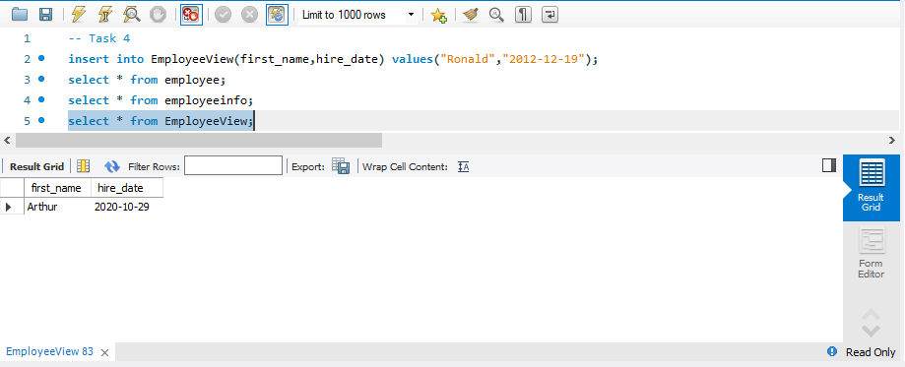

1. Using EmployeeView, add a new employee with hiring date “16-08-2020”. Display all the records

in Employees, EmployeeInfo, and EmployeeView.

